Meet and share with Children of
Mary Bloom Center
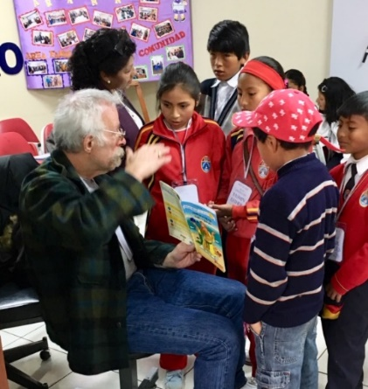

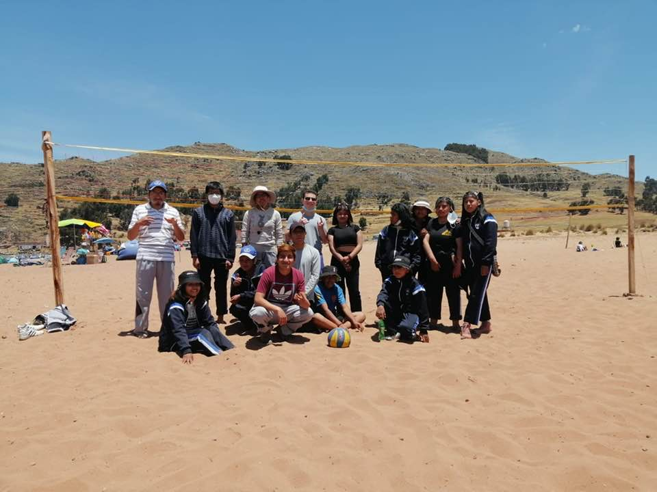

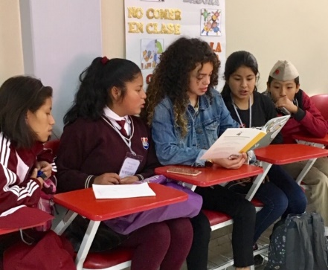

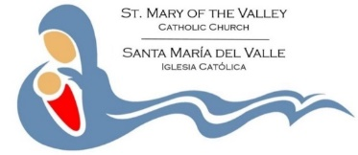
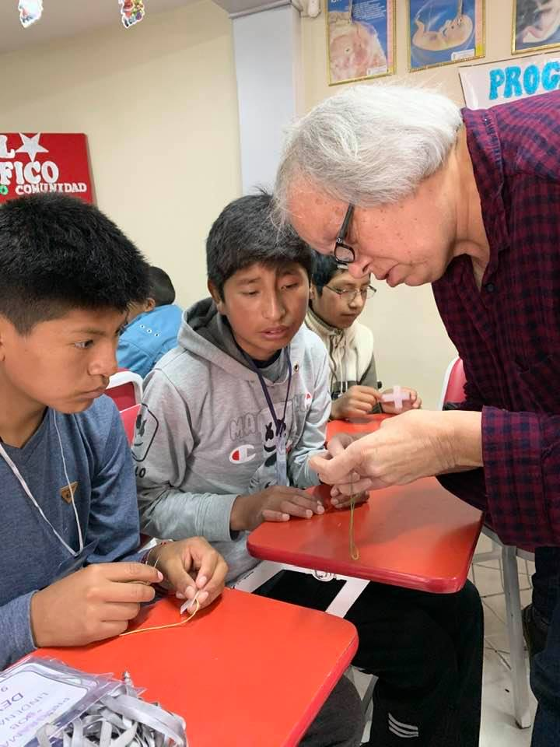
Total Cost: $2,950
Includes Round Trip Airfare Seattle to Lima
Travel and Lodging in Peru
(Special rate for youth/young adults)

Planning meeting
May 24, 2022, 6 pm
at St Mary of the Valley
For more information
http://www.marybloomcenter.org

Fr. Phillip Bloom
St. Mary of Valley
Box 279, Monroe WA 98272
360-794-8945 ext. 12
pbloom@stmaryvalley.org

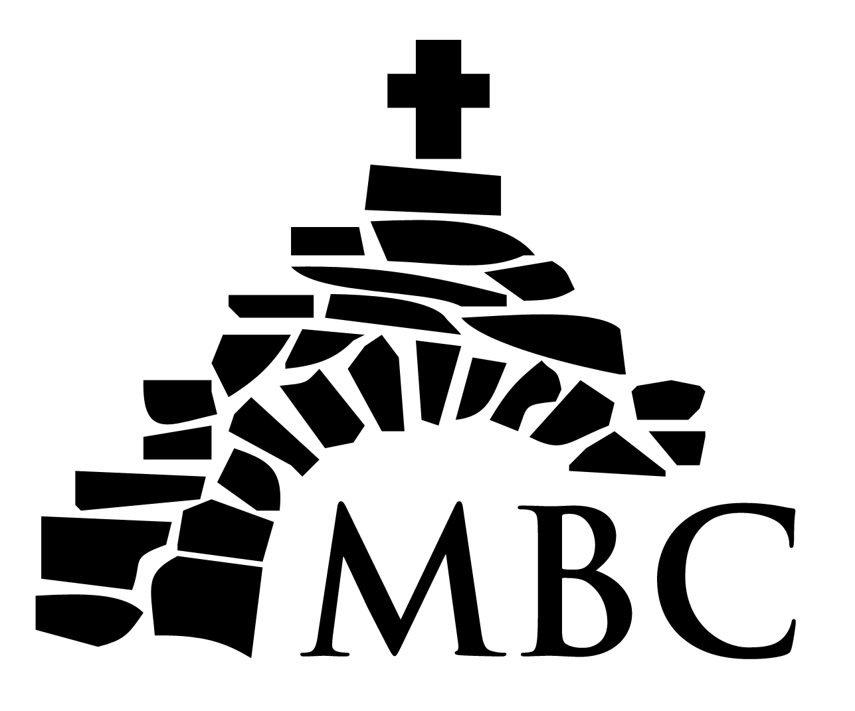
Mary Bloom Center
Vision Trip
June 28 – July 12, 2022
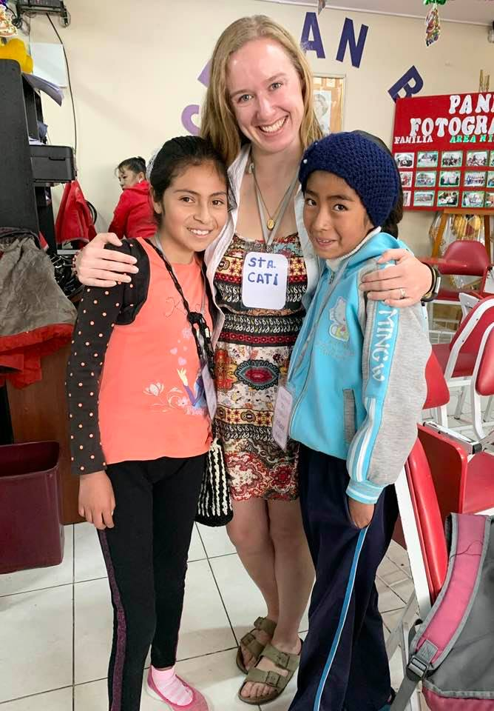

Make a Difference for
Children in Peru!
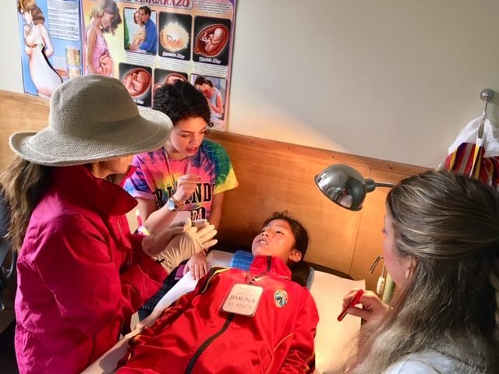
Improving Dental Health
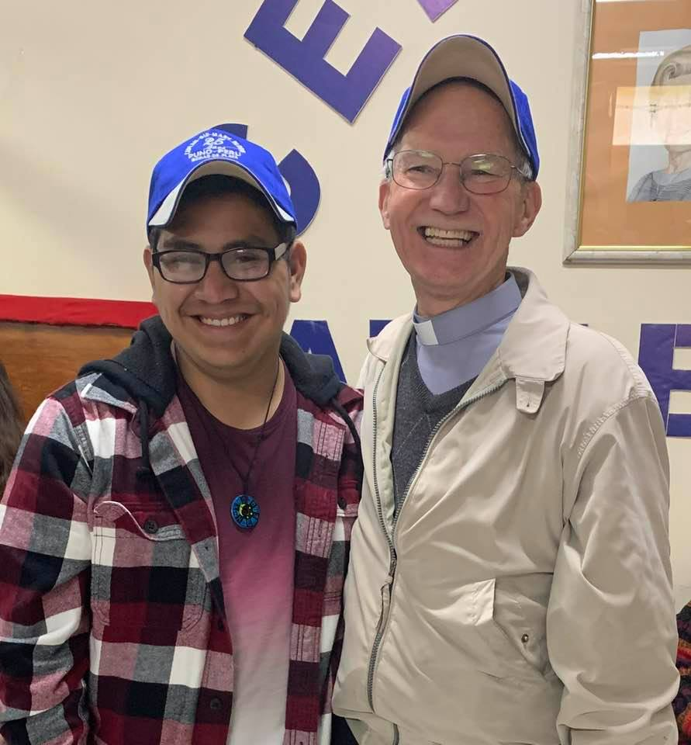
Bilingual Young Adults Appreciated
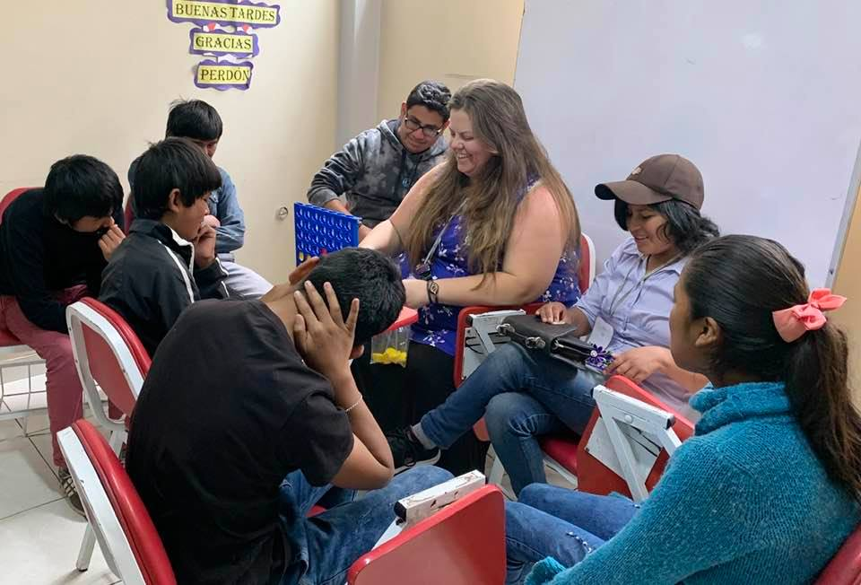
Teaching English, Songs & Crafts
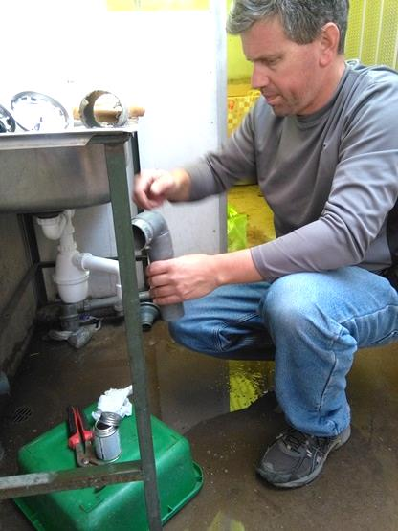
Handymen Needed

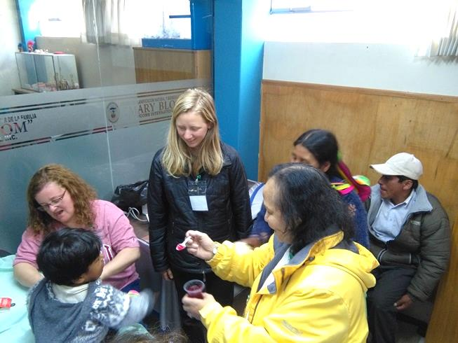
Health Workers Welcomed
Past Delegations
