Meet and share with Children of
Mary Bloom Center
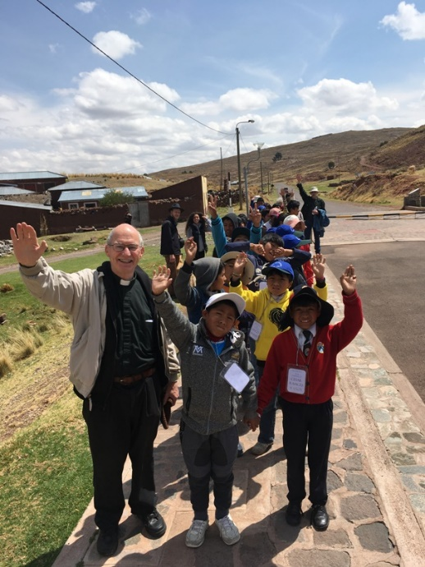

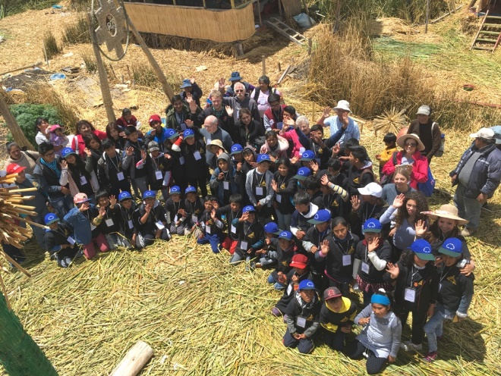

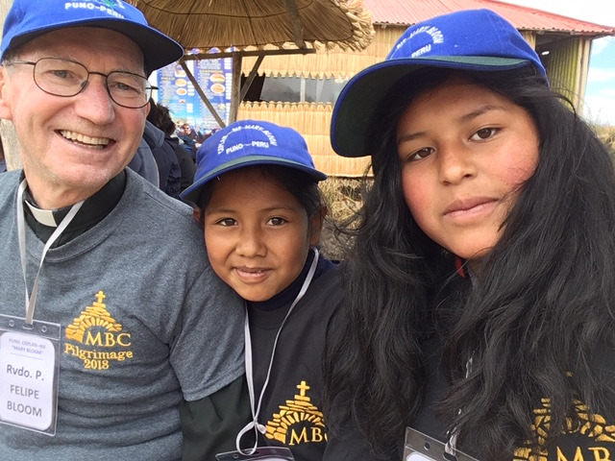

Total Cost: $2,950
Includes Round Trip Airfare Seattle to Lima
Travel and Lodging in Peru

Planning meeting
August 5, 2019
7 pm at St Mary of the Valley
For more information
http://www.marybloomcenter.org

Fr. Phillip Bloom
St. Mary of Valley
Box 279, Monroe WA 98272
360-794-8945 ext. 12
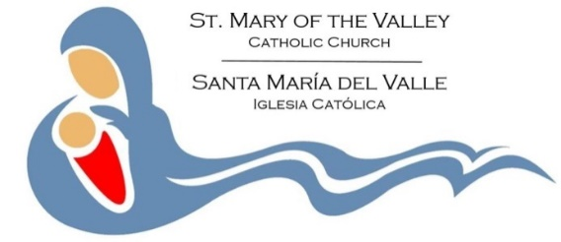
pbloom@stmaryvalley.org

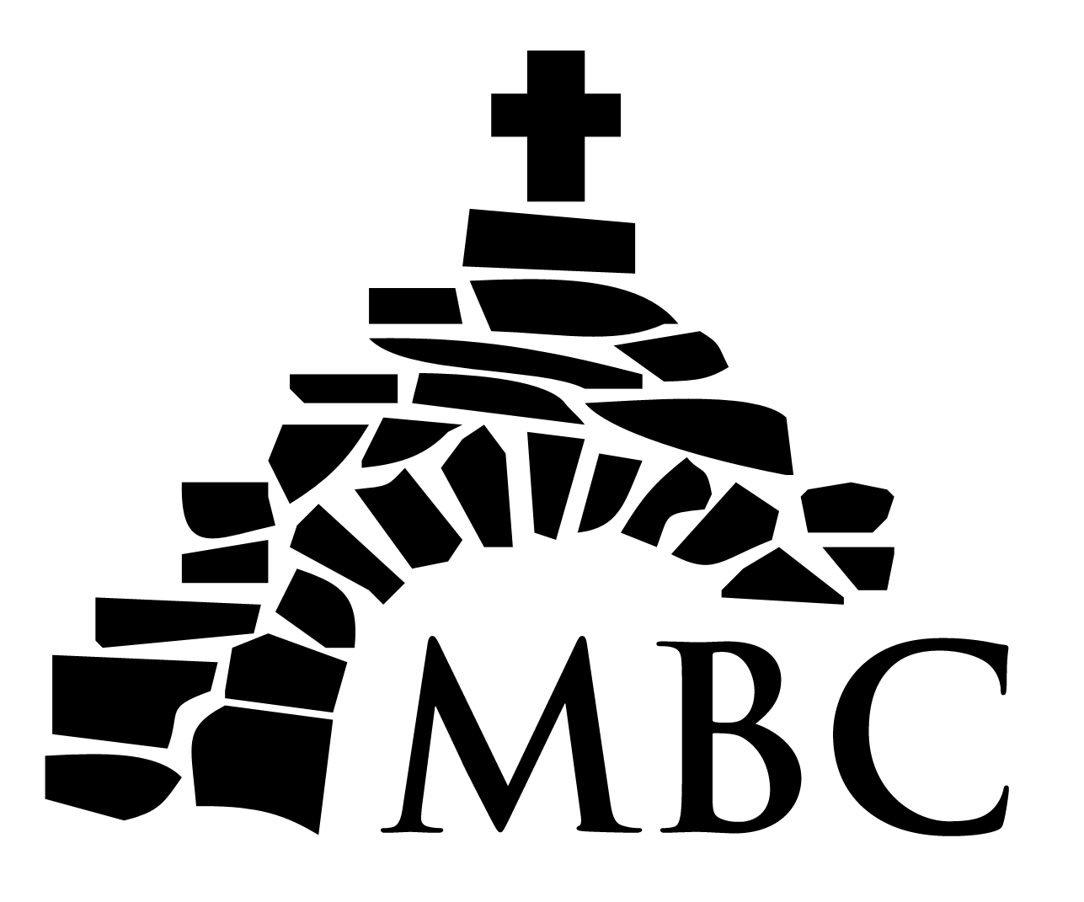
Mary Bloom Center
Mission Trip
December 20, 2019 – January 5, 2020
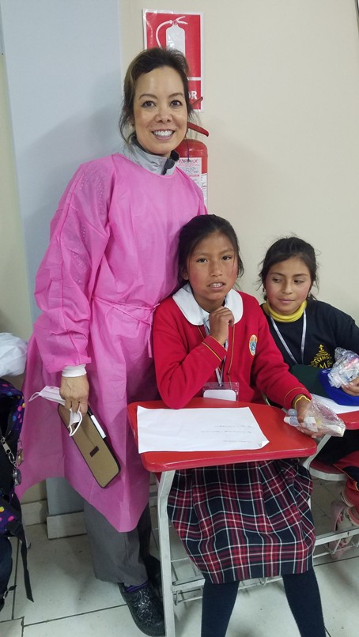

Make a Difference for
Children in Peru!

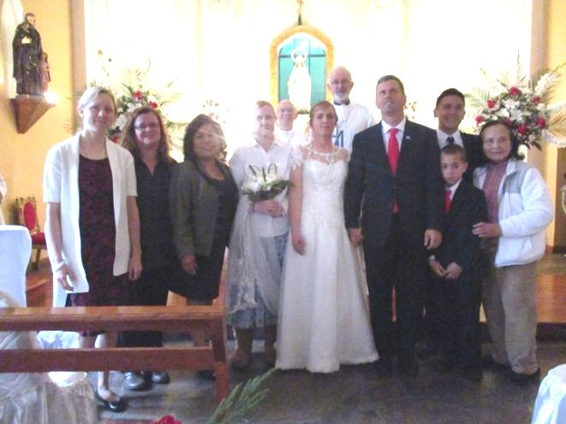
2017 Delegation after Wedding

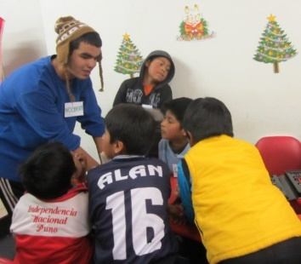
Bilingual Young Adults Appreciated

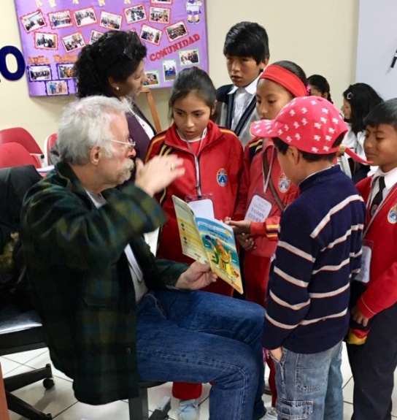
Teaching English, Songs & Crafts
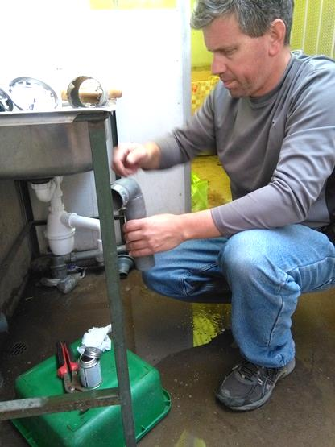
Handymen Needed

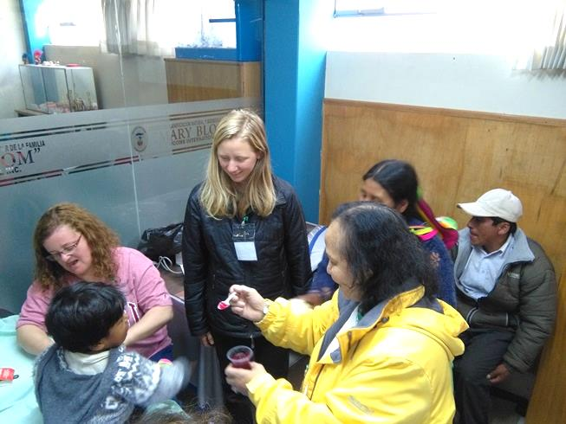
Health Workers Welcomed
Past Delegations

